**Design**

1. Technologies

MS SQL, WebApi2, C#, Entity Framework 6, DI Container Autofac, Repository generic pattern, AngularJS, TypeScript

1. Class diagram

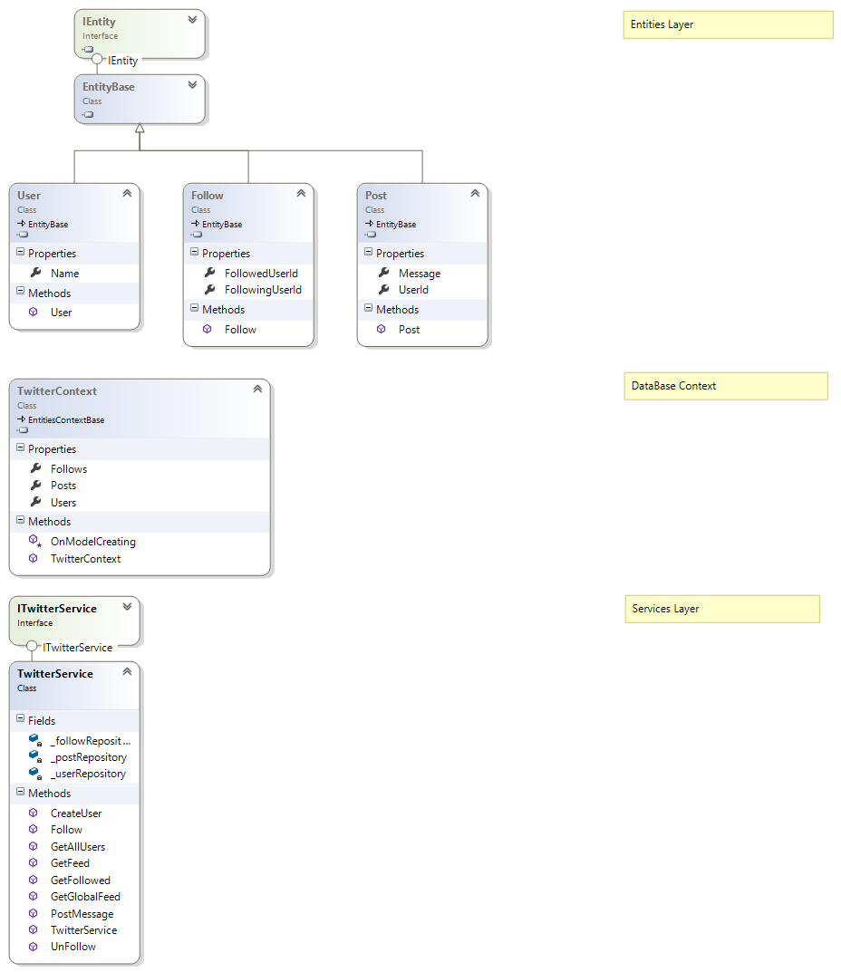

1. End points:

GET: api/twitter/users – get all users

POST: api/twitter/user/create – create new user

POST: api/twitter/user/post – create message

GET: api/twitter/users/{userId}/ feed – get user messages

GET: api/twitter/users/feed – get all messages

POST: api/twitter/user/follow – follow user

POST: api/twitter/user/unfollow – unfollow user

GET: api/twitter/users/{userId}/ followed– get followed users

1. Client part

* endpointService.js
* dto.js
* homeController.js